
Reka Bentuk Antara Muka Berasaskan Web
(CSF3133)

LAB REPORT 4

NAME: CHIA FU YAN
MATRIC: S75039
DATE: 12/11/2024
GROUP: K4
PROGRAM: Computer Science (Software Engineering)
LECTURER: Miss Wan Fatin

4.2 Page Structure Elements
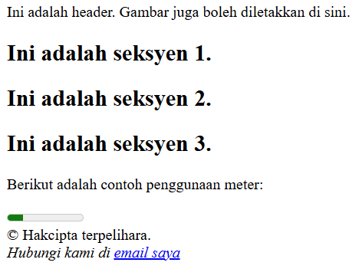

4.3 Insert Video into HTML5 Document
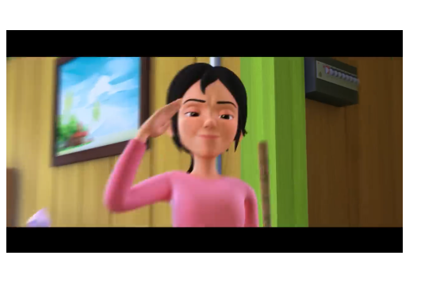

4.4 Cascading Style Sheets
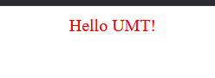

4.5 Recognize ID and Selector Class

stailID.html
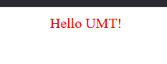

Class.html
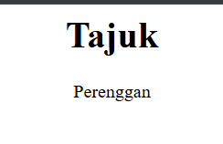

4.6 Navigation Bar Using CSS
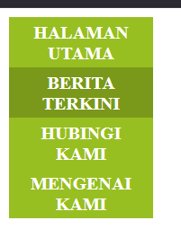

4.7 Recognizing Text Decoration
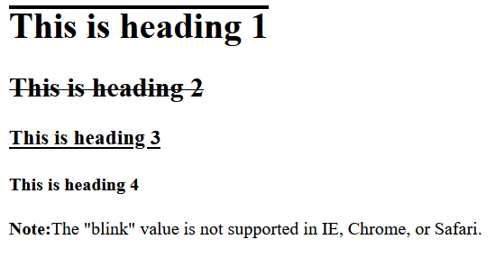

4.8 Recognizing Styling Links

Unvisited
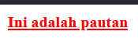
Mouse Over
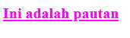
Selected
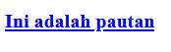
Visited
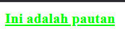

4.9 Lab Exercise 4
Source Code
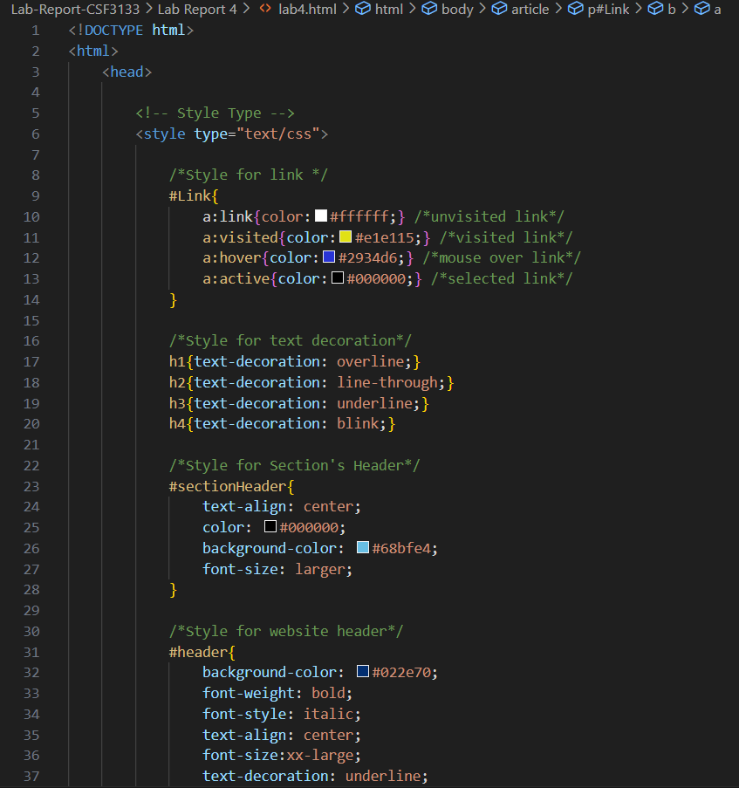
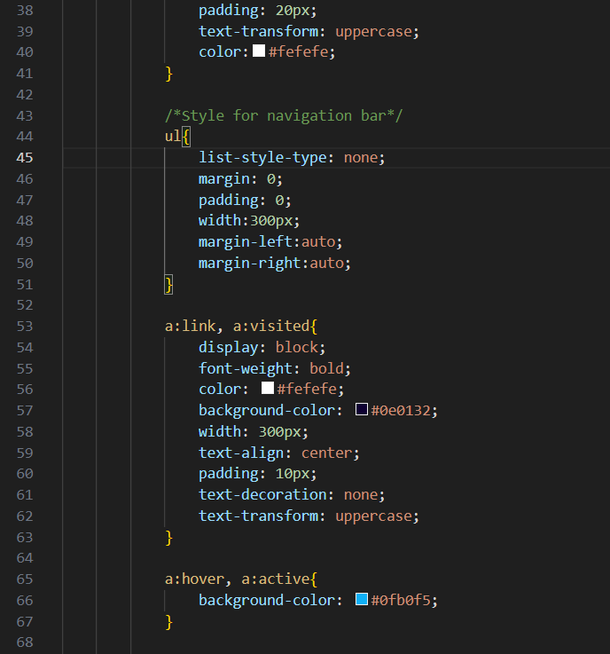
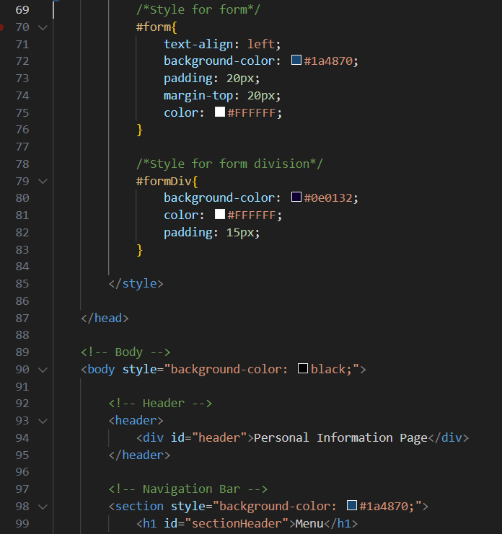
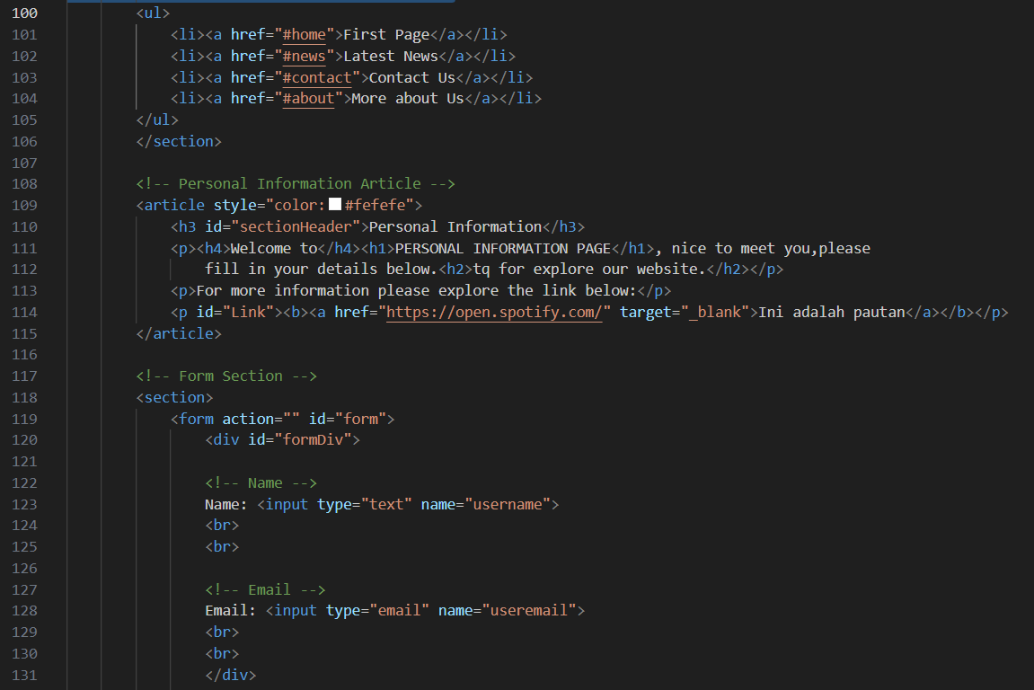
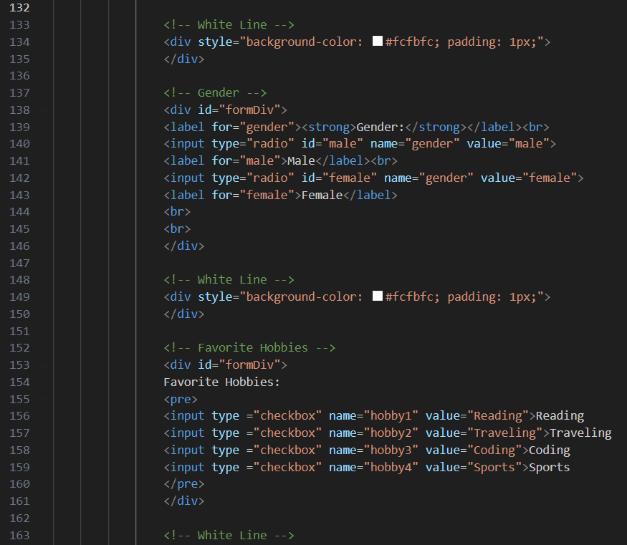
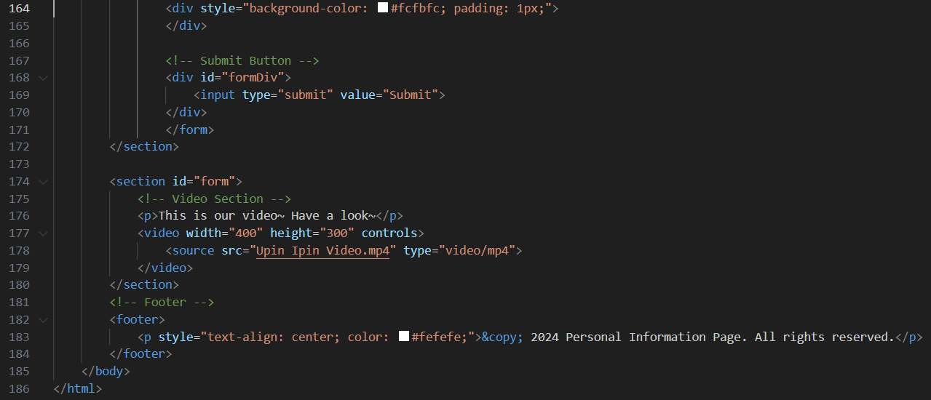
Output
